
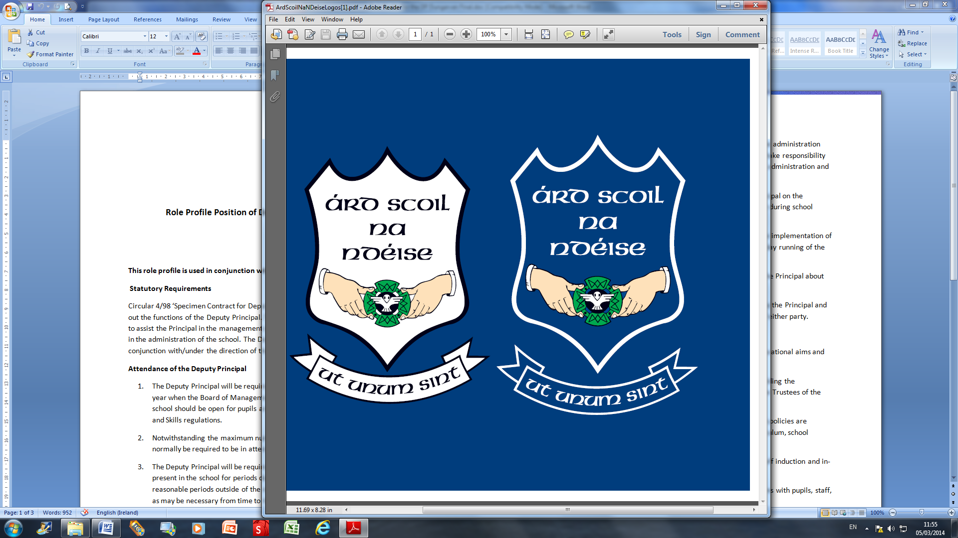

The Board of Management invites applications for the post of

DEPUTY PRINCIPAL
Deputy Principal

To take effect from September 1st, 2014 in Árd Scoil na nDéise, Dungarvan.
Roll Number: 64900W

This all girls’ voluntary Catholic secondary school is in the
trusteeship of CEIST and is conducted in accordance with CEIST
Charter Values (current enrolment 359).

The application form and further documentation can be received from www.ardscoildungarvan.com

Completed typed application forms should be returned to
Chairperson,
Board of Management, Árd Scoil na nDéise, Convent Road, Dungarvan, Co. Waterford.

Application forms will be accepted up to noon on
Friday March 28th, 2014

CEIST Charter is available on the CEIST website

Short-listing may apply.

The Board of Management is an equal opportunities employer.

