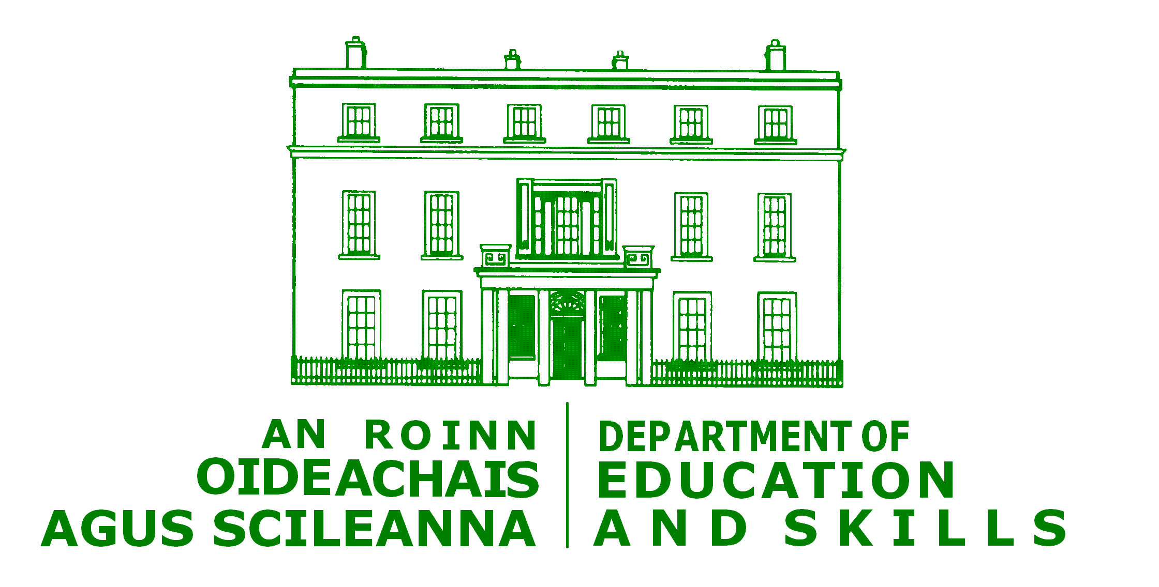


Department of Education Circular 0047/2010

Personal Data of Students

Notice to Parents, Guardians and Students aged 18 years and over, on how the personal data of students enrolled at this post primary school as at 30th September, is returned to the Department of Education and Skills, to primarily secure teaching posts and core funding; and how these data are processed fairly and in compliance with the Data Protection Acts 1988 to 2003.

Introduction
For the Department of Education and Skills to be able to allocate teaching staff and core funding to this post primary school to meet your child’s educational needs, the Department must collect individual and personal data on each student enrolled in each recognised post primary school, at 30th September each year.

This notice sets out the details of the personal data being collected, its purpose, what other bodies these data are shared with and why; how the Department securely stores these data and the Department’s retention of these data.

Purposes of Collecting Individual Student Data
Teaching posts and core funding are allocated to post primary schools by the Department of Education and Skills each year, based on the number of recognised students enrolled in each post primary school, as at 30th September in the previous year.

The Department has detailed in The Rules and Programme for Secondary Schools the criteria for a recognised student in post primary schools. While the full set of rules is available on the Department’s website, www.education.ie, examples include:
- a student meeting the minimum age requirement for their course and that they are following an approved course, e.g. Junior Certificate, and
- given Irish is a compulsory subject for all post primary students, those students not studying Irish must have been granted an exemption from Irish by the school authorities, in accordance with criteria for granting such exemptions.

Hence for each post primary school to have the appropriate levels of teaching posts and core funding to meet your child’s educational needs, each post primary school is required to transfer individualised date on each student enrolled in our school to the Department, as part of what is commonly referred to as the school’s October Return. Much of these data the school would have to assist its management of the school, but some data schools collect specifically for the purpose of making this return.

The core funding allocated to schools includes provision of English Language Support to those students with limited or no knowledge of English and additional resources to meet the educational needs of children who are members of the Travelling Community.

The Department has to meet many national and international statistical, policy and research requirements. The Department does not use individual data from these returns for these functions. However the Department aggregates the individual data for these purposes as well as assisting its wider planning functions.

How is the October Return Made and Where and How are the Data Stored?
Post primary schools return their data electronically through the secure esinet network system. The data received by the Department from post primary schools through the October Returns is stored by the Department in its secure database, called the Post Primary Pupil Database. It is Departmental policy that only a small number of staff who have a requirement to view these personal data for work purposes can gain access to these data.

Upon receipt, the Principal Officer, Parents’ Learners’ and Database Section of Schools’ Division becomes the data controller for these data. The Department of Education and Skills is committed to
- abiding by the Data Protection Acts 1988 to 2003,
- respecting peoples’ rights to confidentiality and for privacy, and
- keeping up to date all data about recognised students stored on its database.

What personal data is collected?
A list of the specific data collected on each student and the purpose for which each item is collected is attached for your information.

What Bodies Does the Department Share Some of the Individual Data With?
As it is necessary to return individualised data to the Department, the Department uses each student’s Personal Public Service Number as a unique identifier. As part of validating that each student returned by post primary schools is a recognised student, the Department transfers a limited amount of each individual student’s personal data to the Department of Social Protection. This includes each child’s PPS number. The legal basis for this sharing of data is set out in Social Welfare Acts.
Sharing a limited amount of the personal data with the Department of Social Protection is also important to:
- identify students that have similar details. For example, a student can only be enrolled in one school as at 30th September,
- in cases where a child’s PPSN number is not available, their individual identity can be determined from the student personal data together with her/his mother’s maiden name,
- identify the movement of students between schools over their time within the education system while allowing their course data from different schools to be accessed for recognition purposes.
Hence a student’s PPS number provided through the October Returns is to provide a unique identifier for each student and as part of validating that each student is a recognised student.
The Department does share some of the personal data with other State bodies. These are:
- data on students enrolled in exam years with the State Examinations Commission to assist its planning for state examinations,
- Central Statistics Office, under the Statistics Acts to assist with the compilation of national statistics, and
- data on 15 years old students, excluding their PPS number to the Educational Research Centre to meet its research requirements which includes some of Ireland’s international research requirements. This Centre subsequently liaises with post primary schools in respect of further data it may require on individual students to assist their research requirements.
The Department has a data user agreement with each of these bodies, which includes the purpose for which the body requires these data, its storage, security and retention. Details of existing data user agreements are available on the Department’s website at www.education.ie (and search for October Returns).

Retention of student data
The Department retains personal data on each student up to their 25th birthday and subject to review thereafter. Since 1991, the Department has retained all individual data on students returned by post primary schools via their October Return. The purpose of this retention policy serves to trace student retention, is important for research and policy formation as well as being an important statistical indicator nationally and internationally. Again aggregate and not individual data is used for these purposes.

Individual records are also retained to meet individual requests from former students which may require it for employment or other purposes. The Post Primary Pupil Database is currently the only national archive of student enrolment at post primary schools.

The Department is continually reviewing its retention policy for student data in consultation with the Office of the Data Protection Commissioner and will update its retention policy from time to time. Any amendments will be available on the Department’s website, www.education.ie

Accessing Personal Information
As part of the fair processing of these data for the October Returns by and between post primary schools and the Department of Education and Skills, post primary schools seek the consent from parents or guardians of children under 18 years and directly from students over 18 years of age.

This notice informs parents and students of the data collected through the October Returns and its uses. No written consent is required except in the cases of what is termed sensitive personal data. In the case of the October Returns the Data Protection Commissioner’s Office has advised that two data fields fall under this category, namely 1st year student’s medical card eligibility and membership of any student to the Travelling Community.

Post primary school authorities are required to gain the written consent from the relevant parents/guardians and students before returning individualised data on these two data fields. If either of these data fields apply to your child, or if you are an enrolled student and aged over 18 years and these data fields apply to you; you are asked to complete the attached form and return it to your post primary school, before 30th September. This form will be retained by the post-primary school and will be made available for inspection by authorised offices of the Department or from the Office of the Data Protection Commissioner.

The Department of Education and Skills is committed to respecting the privacy and confidentiality of all parents and guardians and their children’s personal data and has taken all reasonable measures to do so.

Information which the Department stores on you or your child on its Post Primary Pupil Database is available to you. If you would like copy of these details please write to the

Parents’ Learners and Database Section
Schools’ Division
Cornamaddy
Athlone
Co. Westmeath.

You have the right to object to the processing of your or your child’s personal data, to block certain uses of the data and also in the unlikely event that you identify any errors in the data held about you or your child, you have the right to correct such errors.

Further information on the October returns is available on the Department’s website at www.education.ie (and search for October Returns).

Personal Data returned by Schools to the Department of Education and Skills, as part of their October Return, and which Data the Department of Education and Skills Shares with the Department of Social Protection, and is returned to solely assist the Department of Education and Skills Policy, Planning and Statistical Functions.

Personal Data Transferred to Department of Social Protection

Data Collected on each Student | Purpose
Personal Public Sector Number – PPSN collected for first time in 2001/02 | Unique identifier for each student.
Student Name | Used to validate PPSN and also to identify students who have Irish Exemptions or studied Computer Studies. Also used to contact students if consent is needed to include them in educational surveys etc.
Student Home Address
Date of Birth | There are minimum age threshold for students following different programmes.
Gender | Statistical analysis and to assist with individual student identity.
Mother’s maiden name | PPSN validation. This is removed from the Department’s records when confirmation of valid PPSN is received.

Other Personal Data Returned by Schools to the Department of Education and Skills necessary to identify a student as a recognised student, in accordance with the Rules and Programme for Secondary Schools.

Data Collected on each Student | Purpose
Previous school details | Used for statistical analysis and to ensure progression within the educational system is in accordance with the Rules and Programme for Secondary Schools
Programme – Junior, Leaving, PLC etc. | Used to establish if a student is following prescribed programmes as per Rules and Programme for Secondary Schools. For exam year students it is shared with the State Examination Commission to assist its preparation and organisation of State Examinations.
Subjects
Subject Level
Subject being taken through Irish

Application for English Language Support (first sought in 2009/10) | Additional resources are provided to schools which have children in need of English Language Support

Data Collected on each Student | Purpose
Application for Traveller Support (first sought in 2009/10) | Additional teaching hours are provided for children who are members of the Traveller community. Written Consent is required by school authorities before they can include this in their returns to the Department.
Exemption from studying Irish | Irish is compulsory unless a student has obtained an exemption
Whether student is a boarder | Necessary for school funding considerations
Whether student is Repeating Leaving Certificate | Necessary for school funding considerations and the collection of Repeat Leaving Certificate fee
School Roll No. | Student must be enrolled in a school
Ab initio Indicator | Leaving Cert student may be doing a modern language at Junior Cert
Dispersed VTOS | Identified if student is following a course in this mode

Personal Data returned by Post Primary Schools to the Department to Assist with the Department’s Policy, Statistical, Research and Planning Functions only.

Data Collected on each Student |  | Purpose
 | Country of Birth from 2009/10 onwards in earlier years Country of Origin |  | Used solely for statistical analysis
Medical Card Indicator – first sought in 2009/10 |  | To aid the development of policy to promote social inclusion. Written Consent is required by school authorities before they can include this in their returns to the Department.
Reason for Irish exemption |  | Statistical analysis
Educational attainment |  | PLC students only for statistical analysis and development of educational policy in area of Further Education.
Date of leaving school |  | Early school leavers only for Retention Policy and Statistical analysis
Reason for leaving |  | For statistical and research purposes.

Schools also identify students by reference to being an exam entrant. This data assists the transfer of data on these students only to the State Examinations Commission, to assist its planning of state examinations.
SCHOOL LOGO

Consent Form for Sensitive Personal Data for the School’s October Return to the Department of Education and Skills

Certain sensitive personal data which the Department asks post-primary schools to furnish via the “Annual Post-Primary School October Return/Examination Entries” process requires your written consent for your child’s school to record this information and for the school to forward this information to the Department for purposes as outlined in circular 0047/2010 a copy which is available at www.education.ie or on request from your child’s school.

Please note that the reference to “you” in this consent form means a parent or a guardian of a student, or a student aged 18 years and over who is attending a recognised post-primary school.

Please enter the following details in BLOCK CAPITALS

Name of School: ____________________________________________________

Name of Parent/Guardian: ____________________________________________________

Name of Student: ____________________________________________________

Class year of student ___________________________

1. Where your child is currently in 1st Year do you or your child possess a medical card?
(please CIRCLE the appropriate answer)

YES NO

2. Is your child a member of the Traveller Community *?
(please CIRCLE the appropriate answer)

YES NO

* “Traveller Community” means the community of people who are commonly called Travellers and who are identified (both by themselves and others) as people with a shared history, culture and traditions including, historically, a nomadic way of life on the island of Ireland. Section 2(1) of the Equal Status Act, 2000

Signed: ___________________________

Parent/Guardian/Student

Date: ____________________________

Please complete this form and return to your post-primary school. This form will be retained by the post-primary school and will be made available for inspection by authorised officers of the Department or from the Office of the Data Protection Commissioner.

